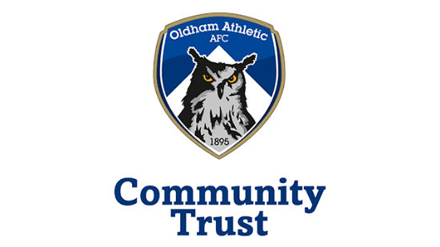

NCS Youth Engagement Officer
Job Location: -
Boundary Park, Furtherwood Road, Oldham, OL1 2PA
Job Purpose: -
Oldham Athletic Community Trust are looking for a professional, dedicated and inclusive individual to support the successful delivery of the National Citizen Service (NCS) programme in Oldham. The role will entail recruitment and retention of young people aged 15-17 onto the programme, in addition to planning the programme timetable and support with delivering a successful programme over the Summer.
Key responsibilities and activities: -
- Supporting with recruitment activities including co-presenting assemblies, follow-up events and school support sessions, building relationships with young people and encouraging them to sign up to NCS.
- Supporting with the retention strategy to manage attrition rates, helping to plan and deliver sessions in the lead-up to programme delivery to ensure young people turn up to their assigned programme.
- Support with the development and delivery of the activity timetable, ensuring it meets the NCS Programme Quality Framework.
- Build strong working relationships with both internal and external stakeholders including teachers, parents/guardians, the local authority and local charities.
- To support delivery seasonally through taking on a delivery staff role, on programmes assigned, including residential aspects of the programme.
- Accurately process and manage data in Salesforce CRM system.
- Support the NCS Manager with hitting contractual targets for recruitment and programme delivery.
- Responsibility for the safeguarding of young people, both participating and working on programme.

Person Specification: -
Essential skills, experiences and qualifications:
- Experience of, or enthusiasm for, working with young people, particularly 15-17 year-olds.
- Good communication skills including written, telephone and interpersonal skills and ability to deliver presentations.
- Ability to build relationships and rapport quickly.
- IT literate with emphasis on Microsoft and Google packages.
- Good time management and organisational skills to manage time and priorities effectively.
- Good level of general education (5 GCSE’s A*-C, or equivalent Level 2 qualifications).
- Good understanding, or willingness to understand, the needs of the local community and young people in Oldham.
- Driving licence and access to own vehicle preferred but not essential.

Working pattern:-
25 hours per week, typically 5 hours/day Monday – Friday but flexible working pattern is possible to suit the needs of the individual and the organisation. Additional hours may be required during NCS programme delivery, including overnight stays.
Salary:-
National Minimum Wage (age-dependent)
Training opportunities:-
- Gain knowledge and experience of the NCS programme.
- Opportunity to attend training and CPD within the EFL and NCS Trust networks
- Gain an understanding of the wider business and opportunity to support on different projects.
- Access to support from OACT Employability Lead to support transition into full-time employment.
- Potential of full-time/part-time role beyond the 6 months, subject to increased contracted participant numbers and continued funding for NCS project.
- Ongoing 1-to-1 support from NCS Manager.

How to apply:-
To be eligible for this role, you must be aged 16-24 and claiming Universal Credit. Speak to your Job Centre Work Coach for a referral.

